1008

BATCH_SIZE= 64

iter 0: Train accuracy 0.21875 Test accuracy: 0.235 *

iter 100: Train accuracy 0.703125 Test accuracy: 0.626 *

iter 200: Train accuracy 0.59375 Test accuracy: 0.6315 *

iter 300: Train accuracy 0.625 Test accuracy: 0.6305

iter 400: Train accuracy 0.703125 Test accuracy: 0.6335 *

iter 500: Train accuracy 0.5625 Test accuracy: 0.633

iter 600: Train accuracy 0.609375 Test accuracy: 0.6345 *

iter 700: Train accuracy 0.671875 Test accuracy: 0.634

iter 800: Train accuracy 0.546875 Test accuracy: 0.637 *

iter 900: Train accuracy 0.671875 Test accuracy: 0.6375 *

iter 1000: Train accuracy 0.734375 Test accuracy: 0.6395 *

iter 1100: Train accuracy 0.609375 Test accuracy: 0.641 *

iter 1200: Train accuracy 0.765625 Test accuracy: 0.642 *

iter 1300: Train accuracy 0.6875 Test accuracy: 0.644 *

iter 1400: Train accuracy 0.71875 Test accuracy: 0.6465 *

iter 1500: Train accuracy 0.65625 Test accuracy: 0.6485 *

iter 1600: Train accuracy 0.71875 Test accuracy: 0.6535 *

iter 1700: Train accuracy 0.75 Test accuracy: 0.666 *

iter 1800: Train accuracy 0.78125 Test accuracy: 0.6845 *

iter 1900: Train accuracy 0.71875 Test accuracy: 0.696 *

iter 2000: Train accuracy 0.6875 Test accuracy: 0.711 *

iter 2100: Train accuracy 0.75 Test accuracy: 0.729 *

iter 2200: Train accuracy 0.78125 Test accuracy: 0.744 *

iter 2300: Train accuracy 0.75 Test accuracy: 0.753 *

iter 2400: Train accuracy 0.828125 Test accuracy: 0.7595 *

iter 2500: Train accuracy 0.78125 Test accuracy: 0.764 *

iter 2600: Train accuracy 0.78125 Test accuracy: 0.765 *

iter 2700: Train accuracy 0.828125 Test accuracy: 0.77 *

iter 2800: Train accuracy 0.828125 Test accuracy: 0.7745 *

iter 2900: Train accuracy 0.859375 Test accuracy: 0.777 *

iter 3000: Train accuracy 0.78125 Test accuracy: 0.7785 *

iter 3100: Train accuracy 0.78125 Test accuracy: 0.78 *

iter 3200: Train accuracy 0.75 Test accuracy: 0.7825 *

iter 3300: Train accuracy 0.890625 Test accuracy: 0.7835 *

iter 3400: Train accuracy 0.84375 Test accuracy: 0.785 *

iter 3500: Train accuracy 0.859375 Test accuracy: 0.786 *

iter 3600: Train accuracy 0.796875 Test accuracy: 0.788 *

iter 3700: Train accuracy 0.875 Test accuracy: 0.7885 *

iter 3800: Train accuracy 0.84375 Test accuracy: 0.7875

iter 3900: Train accuracy 0.828125 Test accuracy: 0.788

iter 4000: Train accuracy 0.859375 Test accuracy: 0.789 *

iter 4100: Train accuracy 0.8125 Test accuracy: 0.7895 *

iter 4200: Train accuracy 0.828125 Test accuracy: 0.7905 *

iter 4300: Train accuracy 0.859375 Test accuracy: 0.791 *

iter 4400: Train accuracy 0.8125 Test accuracy: 0.7915 *

iter 4500: Train accuracy 0.796875 Test accuracy: 0.7925 *

iter 4600: Train accuracy 0.765625 Test accuracy: 0.793 *

iter 4700: Train accuracy 0.84375 Test accuracy: 0.7945 *

iter 4800: Train accuracy 0.78125 Test accuracy: 0.7945

iter 4900: Train accuracy 0.78125 Test accuracy: 0.796 *

iter 4999: Train accuracy 0.859375 Test accuracy: 0.7965 *

Time usage: 0:09:08

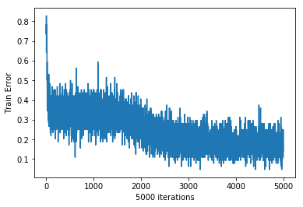

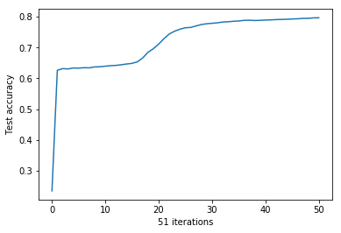

BATCH_SIZE= 32

iter 0: Train accuracy 0.09375 Test accuracy: 0.235 *

iter 100: Train accuracy 0.6875 Test accuracy: 0.6315 *

iter 200: Train accuracy 0.78125 Test accuracy: 0.6335 *

iter 300: Train accuracy 0.6875 Test accuracy: 0.6335

iter 400: Train accuracy 0.65625 Test accuracy: 0.635 *

iter 500: Train accuracy 0.65625 Test accuracy: 0.64 *

iter 600: Train accuracy 0.5625 Test accuracy: 0.6415 *

iter 700: Train accuracy 0.84375 Test accuracy: 0.647 *

iter 800: Train accuracy 0.78125 Test accuracy: 0.654 *

iter 900: Train accuracy 0.625 Test accuracy: 0.6885 *

iter 1000: Train accuracy 0.75 Test accuracy: 0.7105 *

iter 1100: Train accuracy 0.71875 Test accuracy: 0.745 *

iter 1200: Train accuracy 0.75 Test accuracy: 0.759 *

iter 1300: Train accuracy 0.78125 Test accuracy: 0.767 *

iter 1400: Train accuracy 0.84375 Test accuracy: 0.775 *

iter 1500: Train accuracy 0.78125 Test accuracy: 0.78 *

iter 1600: Train accuracy 0.84375 Test accuracy: 0.7815 *

iter 1700: Train accuracy 0.84375 Test accuracy: 0.7855 *

iter 1800: Train accuracy 0.75 Test accuracy: 0.7875 *

iter 1900: Train accuracy 0.75 Test accuracy: 0.788 *

iter 2000: Train accuracy 0.90625 Test accuracy: 0.7885 *

iter 2100: Train accuracy 0.84375 Test accuracy: 0.79 *

iter 2200: Train accuracy 0.8125 Test accuracy: 0.7915 *

iter 2300: Train accuracy 0.9375 Test accuracy: 0.7935 *

iter 2400: Train accuracy 0.8125 Test accuracy: 0.7945 *

iter 2500: Train accuracy 0.625 Test accuracy: 0.797 *

iter 2600: Train accuracy 0.8125 Test accuracy: 0.797

iter 2700: Train accuracy 0.90625 Test accuracy: 0.797

iter 2800: Train accuracy 0.71875 Test accuracy: 0.799 *

iter 2900: Train accuracy 0.875 Test accuracy: 0.8005 *

iter 3000: Train accuracy 0.65625 Test accuracy: 0.801 *

iter 3100: Train accuracy 0.71875 Test accuracy: 0.802 *

iter 3200: Train accuracy 0.84375 Test accuracy: 0.802

iter 3300: Train accuracy 0.78125 Test accuracy: 0.8035 *

iter 3400: Train accuracy 0.875 Test accuracy: 0.805 *

iter 3500: Train accuracy 0.78125 Test accuracy: 0.805

iter 3600: Train accuracy 0.84375 Test accuracy: 0.806 *

iter 3700: Train accuracy 0.8125 Test accuracy: 0.806

iter 3800: Train accuracy 0.84375 Test accuracy: 0.807 *

iter 3900: Train accuracy 0.71875 Test accuracy: 0.8085 *

iter 4000: Train accuracy 0.84375 Test accuracy: 0.809 *

iter 4100: Train accuracy 0.75 Test accuracy: 0.8085

iter 4200: Train accuracy 0.875 Test accuracy: 0.8085

iter 4300: Train accuracy 0.71875 Test accuracy: 0.8085

iter 4400: Train accuracy 0.90625 Test accuracy: 0.808

iter 4500: Train accuracy 0.875 Test accuracy: 0.809

iter 4600: Train accuracy 0.75 Test accuracy: 0.8095 *

iter 4700: Train accuracy 0.90625 Test accuracy: 0.81 *

iter 4800: Train accuracy 0.9375 Test accuracy: 0.81

iter 4900: Train accuracy 0.71875 Test accuracy: 0.8105 *

iter 4999: Train accuracy 0.875 Test accuracy: 0.81

Time usage: 0:16:18

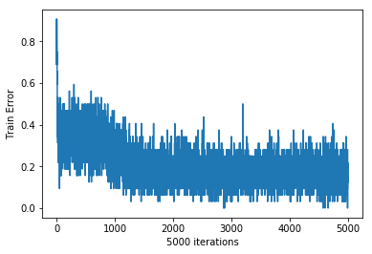

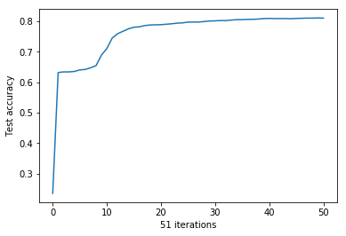

BATCH_SIZE= 16

iter 0: Train accuracy 0.25 Test accuracy: 0.235 *

iter 100: Train accuracy 0.625 Test accuracy: 0.6335 *

iter 200: Train accuracy 0.375 Test accuracy: 0.6345 *

iter 300: Train accuracy 0.75 Test accuracy: 0.642 *

iter 400: Train accuracy 0.4375 Test accuracy: 0.656 *

iter 500: Train accuracy 0.5625 Test accuracy: 0.7215 *

iter 600: Train accuracy 0.9375 Test accuracy: 0.7605 *

iter 700: Train accuracy 0.8125 Test accuracy: 0.7765 *

iter 800: Train accuracy 0.75 Test accuracy: 0.7805 *

iter 900: Train accuracy 0.6875 Test accuracy: 0.7885 *

iter 1000: Train accuracy 0.875 Test accuracy: 0.7885

iter 1100: Train accuracy 0.875 Test accuracy: 0.7925 *

iter 1200: Train accuracy 0.875 Test accuracy: 0.7945 *

iter 1300: Train accuracy 0.875 Test accuracy: 0.798 *

iter 1400: Train accuracy 0.9375 Test accuracy: 0.8 *

iter 1500: Train accuracy 0.8125 Test accuracy: 0.802 *

iter 1600: Train accuracy 0.75 Test accuracy: 0.804 *

iter 1700: Train accuracy 0.9375 Test accuracy: 0.805 *

iter 1800: Train accuracy 0.9375 Test accuracy: 0.806 *

iter 1900: Train accuracy 1 Test accuracy: 0.8065 *

iter 2000: Train accuracy 0.875 Test accuracy: 0.807 *

iter 2100: Train accuracy 0.875 Test accuracy: 0.808 *

iter 2200: Train accuracy 0.8125 Test accuracy: 0.8085 *

iter 2300: Train accuracy 0.8125 Test accuracy: 0.81 *

iter 2400: Train accuracy 0.9375 Test accuracy: 0.811 *

iter 2500: Train accuracy 0.625 Test accuracy: 0.8115 *

iter 2600: Train accuracy 0.875 Test accuracy: 0.811

iter 2700: Train accuracy 0.9375 Test accuracy: 0.8115

iter 2800: Train accuracy 0.875 Test accuracy: 0.8125 *

iter 2900: Train accuracy 0.9375 Test accuracy: 0.8125

iter 3000: Train accuracy 0.8125 Test accuracy: 0.812

iter 3100: Train accuracy 0.6875 Test accuracy: 0.813 *

iter 3200: Train accuracy 1 Test accuracy: 0.814 *

iter 3300: Train accuracy 0.9375 Test accuracy: 0.814

iter 3400: Train accuracy 0.8125 Test accuracy: 0.816 *

iter 3500: Train accuracy 0.9375 Test accuracy: 0.8155

iter 3600: Train accuracy 0.6875 Test accuracy: 0.8155

iter 3700: Train accuracy 1 Test accuracy: 0.8155

iter 3800: Train accuracy 0.9375 Test accuracy: 0.818 *

iter 3900: Train accuracy 0.8125 Test accuracy: 0.817

iter 4000: Train accuracy 0.9375 Test accuracy: 0.817

iter 4100: Train accuracy 0.9375 Test accuracy: 0.817

iter 4200: Train accuracy 0.75 Test accuracy: 0.8175

iter 4300: Train accuracy 0.9375 Test accuracy: 0.823 *

iter 4400: Train accuracy 0.75 Test accuracy: 0.8205

iter 4500: Train accuracy 0.9375 Test accuracy: 0.822

iter 4600: Train accuracy 0.8125 Test accuracy: 0.8225

iter 4700: Train accuracy 0.8125 Test accuracy: 0.823

iter 4800: Train accuracy 0.75 Test accuracy: 0.822

iter 4900: Train accuracy 1 Test accuracy: 0.8225

iter 4999: Train accuracy 0.8125 Test accuracy: 0.8225

Time usage: 0:30:38

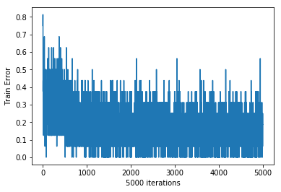

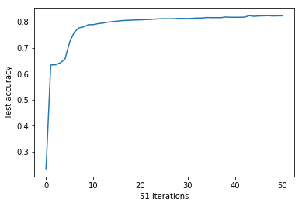

BATCH_SIZE= 8

iter 0: Train accuracy 0.25 Test accuracy: 0.235 *

iter 100: Train accuracy 0.5 Test accuracy: 0.634 *

iter 200: Train accuracy 0.625 Test accuracy: 0.6585 *

iter 300: Train accuracy 0.875 Test accuracy: 0.7635 *

iter 400: Train accuracy 0.75 Test accuracy: 0.7785 *

iter 500: Train accuracy 0.625 Test accuracy: 0.7895 *

iter 600: Train accuracy 0.75 Test accuracy: 0.795 *

iter 700: Train accuracy 0.875 Test accuracy: 0.8 *

iter 800: Train accuracy 0.875 Test accuracy: 0.8015 *

iter 900: Train accuracy 0.875 Test accuracy: 0.806 *

iter 1000: Train accuracy 0.875 Test accuracy: 0.808 *

iter 1100: Train accuracy 0.875 Test accuracy: 0.8095 *

iter 1200: Train accuracy 0.625 Test accuracy: 0.811 *

iter 1300: Train accuracy 1 Test accuracy: 0.8125 *

iter 1400: Train accuracy 0.875 Test accuracy: 0.8115

iter 1500: Train accuracy 1 Test accuracy: 0.811

iter 1600: Train accuracy 1 Test accuracy: 0.813 *

iter 1700: Train accuracy 1 Test accuracy: 0.813

iter 1800: Train accuracy 0.625 Test accuracy: 0.816 *

iter 1900: Train accuracy 0.75 Test accuracy: 0.8175 *

iter 2000: Train accuracy 0.5 Test accuracy: 0.816

iter 2100: Train accuracy 0.875 Test accuracy: 0.8205 *

iter 2200: Train accuracy 0.875 Test accuracy: 0.822 *

iter 2300: Train accuracy 0.875 Test accuracy: 0.8225 *

iter 2400: Train accuracy 0.875 Test accuracy: 0.823 *

iter 2500: Train accuracy 0.875 Test accuracy: 0.825 *

iter 2600: Train accuracy 0.875 Test accuracy: 0.8225

iter 2700: Train accuracy 0.875 Test accuracy: 0.824

iter 2800: Train accuracy 0.875 Test accuracy: 0.824

iter 2900: Train accuracy 0.875 Test accuracy: 0.824

iter 3000: Train accuracy 0.875 Test accuracy: 0.824

iter 3100: Train accuracy 1 Test accuracy: 0.826 *

iter 3200: Train accuracy 1 Test accuracy: 0.8255

iter 3300: Train accuracy 0.625 Test accuracy: 0.827 *

iter 3400: Train accuracy 1 Test accuracy: 0.826

iter 3500: Train accuracy 1 Test accuracy: 0.8275 *

iter 3600: Train accuracy 0.875 Test accuracy: 0.825

iter 3700: Train accuracy 0.75 Test accuracy: 0.826

iter 3800: Train accuracy 0.875 Test accuracy: 0.827

iter 3900: Train accuracy 0.75 Test accuracy: 0.827

iter 4000: Train accuracy 0.75 Test accuracy: 0.827

iter 4100: Train accuracy 1 Test accuracy: 0.8285 *

iter 4200: Train accuracy 0.75 Test accuracy: 0.829 *

iter 4300: Train accuracy 0.875 Test accuracy: 0.829

iter 4400: Train accuracy 0.875 Test accuracy: 0.83 *

iter 4500: Train accuracy 0.875 Test accuracy: 0.829

iter 4600: Train accuracy 0.75 Test accuracy: 0.8305 *

iter 4700: Train accuracy 0.875 Test accuracy: 0.832 *

iter 4800: Train accuracy 0.75 Test accuracy: 0.8305

iter 4900: Train accuracy 0.875 Test accuracy: 0.831

iter 4999: Train accuracy 0.75 Test accuracy: 0.8305

Time usage: 0:53:25

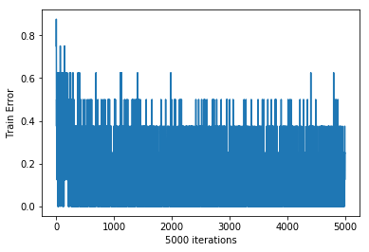

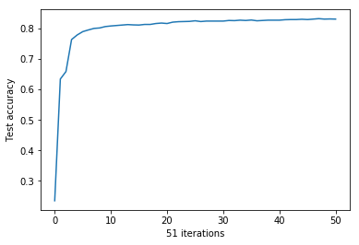

BATCH_SIZE= 4

iter 0: Train accuracy 0.5 Test accuracy: 0.254 *

iter 100: Train accuracy 0.75 Test accuracy: 0.657 *

iter 200: Train accuracy 0.5 Test accuracy: 0.783 *

iter 300: Train accuracy 1 Test accuracy: 0.793 *

iter 400: Train accuracy 0.75 Test accuracy: 0.804 *

iter 500: Train accuracy 1 Test accuracy: 0.8085 *

iter 600: Train accuracy 1 Test accuracy: 0.809 *

iter 700: Train accuracy 0.75 Test accuracy: 0.812 *

iter 800: Train accuracy 1 Test accuracy: 0.8115

iter 900: Train accuracy 1 Test accuracy: 0.8135 *

iter 1000: Train accuracy 0.75 Test accuracy: 0.8175 *

iter 1100: Train accuracy 0.75 Test accuracy: 0.8195 *

iter 1200: Train accuracy 0.75 Test accuracy: 0.818

iter 1300: Train accuracy 0.75 Test accuracy: 0.823 *

iter 1400: Train accuracy 1 Test accuracy: 0.825 *

iter 1500: Train accuracy 0.75 Test accuracy: 0.8255 *

iter 1600: Train accuracy 1 Test accuracy: 0.8255

iter 1700: Train accuracy 1 Test accuracy: 0.826 *

iter 1800: Train accuracy 1 Test accuracy: 0.8255

iter 1900: Train accuracy 0.75 Test accuracy: 0.8295 *

iter 2000: Train accuracy 1 Test accuracy: 0.83 *

iter 2100: Train accuracy 0.75 Test accuracy: 0.829

iter 2200: Train accuracy 0.5 Test accuracy: 0.83

iter 2300: Train accuracy 0.75 Test accuracy: 0.83

iter 2400: Train accuracy 1 Test accuracy: 0.83

iter 2500: Train accuracy 0.75 Test accuracy: 0.8305 *

iter 2600: Train accuracy 0.75 Test accuracy: 0.833 *

iter 2700: Train accuracy 1 Test accuracy: 0.832

iter 2800: Train accuracy 0.75 Test accuracy: 0.834 *

iter 2900: Train accuracy 0.75 Test accuracy: 0.8365 *

iter 3000: Train accuracy 0.75 Test accuracy: 0.837 *

iter 3100: Train accuracy 0.75 Test accuracy: 0.84 *

iter 3200: Train accuracy 0.75 Test accuracy: 0.8385

iter 3300: Train accuracy 0.5 Test accuracy: 0.8405 *

iter 3400: Train accuracy 1 Test accuracy: 0.8385

iter 3500: Train accuracy 0.75 Test accuracy: 0.8405

iter 3600: Train accuracy 1 Test accuracy: 0.841 *

iter 3700: Train accuracy 0.75 Test accuracy: 0.843 *

iter 3800: Train accuracy 1 Test accuracy: 0.8415

iter 3900: Train accuracy 1 Test accuracy: 0.8435 *

iter 4000: Train accuracy 1 Test accuracy: 0.8415

iter 4100: Train accuracy 1 Test accuracy: 0.841

iter 4200: Train accuracy 0.75 Test accuracy: 0.84

iter 4300: Train accuracy 1 Test accuracy: 0.8415

iter 4400: Train accuracy 0.5 Test accuracy: 0.8415

iter 4500: Train accuracy 0.75 Test accuracy: 0.841

iter 4600: Train accuracy 1 Test accuracy: 0.841

iter 4700: Train accuracy 1 Test accuracy: 0.841

iter 4800: Train accuracy 1 Test accuracy: 0.8405

iter 4900: Train accuracy 1 Test accuracy: 0.8405

iter 4999: Train accuracy 1 Test accuracy: 0.841

Time usage: 1:34:45

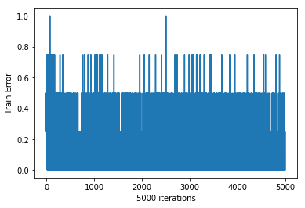

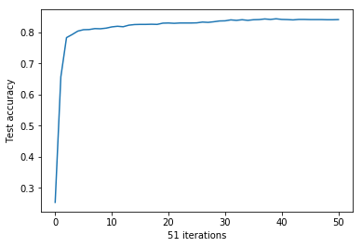

1007

BATCH_SIZE= 64

iter 0: Train accuracy 0.203125 Test accuracy: 0.235 *

iter 100: Train accuracy 0.703125 Test accuracy: 0.626 *

iter 200: Train accuracy 0.59375 Test accuracy: 0.6315 *

iter 300: Train accuracy 0.625 Test accuracy: 0.6305

iter 400: Train accuracy 0.703125 Test accuracy: 0.6335 *

iter 500: Train accuracy 0.5625 Test accuracy: 0.633

iter 600: Train accuracy 0.609375 Test accuracy: 0.6345 *

iter 700: Train accuracy 0.671875 Test accuracy: 0.634

iter 800: Train accuracy 0.546875 Test accuracy: 0.637 *

iter 900: Train accuracy 0.671875 Test accuracy: 0.6375 *

iter 1000: Train accuracy 0.734375 Test accuracy: 0.6395 *

iter 1100: Train accuracy 0.609375 Test accuracy: 0.641 *

iter 1200: Train accuracy 0.765625 Test accuracy: 0.642 *

iter 1300: Train accuracy 0.6875 Test accuracy: 0.644 *

iter 1400: Train accuracy 0.71875 Test accuracy: 0.6465 *

iter 1500: Train accuracy 0.65625 Test accuracy: 0.6485 *

iter 1600: Train accuracy 0.71875 Test accuracy: 0.6535 *

iter 1700: Train accuracy 0.75 Test accuracy: 0.665 *

iter 1800: Train accuracy 0.78125 Test accuracy: 0.684 *

iter 1900: Train accuracy 0.71875 Test accuracy: 0.6955 *

iter 2000: Train accuracy 0.6875 Test accuracy: 0.7095 *

iter 2100: Train accuracy 0.75 Test accuracy: 0.728 *

iter 2200: Train accuracy 0.78125 Test accuracy: 0.7435 *

iter 2300: Train accuracy 0.75 Test accuracy: 0.753 *

iter 2400: Train accuracy 0.828125 Test accuracy: 0.7595 *

iter 2500: Train accuracy 0.78125 Test accuracy: 0.764 *

iter 2600: Train accuracy 0.78125 Test accuracy: 0.7655 *

iter 2700: Train accuracy 0.828125 Test accuracy: 0.7705 *

iter 2800: Train accuracy 0.828125 Test accuracy: 0.7725 *

iter 2900: Train accuracy 0.859375 Test accuracy: 0.7765 *

iter 3000: Train accuracy 0.78125 Test accuracy: 0.779 *

iter 3100: Train accuracy 0.78125 Test accuracy: 0.78 *

iter 3200: Train accuracy 0.75 Test accuracy: 0.7825 *

iter 3300: Train accuracy 0.890625 Test accuracy: 0.784 *

iter 3400: Train accuracy 0.84375 Test accuracy: 0.785 *

iter 3500: Train accuracy 0.859375 Test accuracy: 0.7855 *

iter 3600: Train accuracy 0.796875 Test accuracy: 0.788 *

iter 3700: Train accuracy 0.875 Test accuracy: 0.7885 *

iter 3800: Train accuracy 0.84375 Test accuracy: 0.7875

iter 3900: Train accuracy 0.828125 Test accuracy: 0.788

iter 4000: Train accuracy 0.859375 Test accuracy: 0.789 *

iter 4100: Train accuracy 0.8125 Test accuracy: 0.7895 *

iter 4200: Train accuracy 0.828125 Test accuracy: 0.7905 *

iter 4300: Train accuracy 0.859375 Test accuracy: 0.791 *

iter 4400: Train accuracy 0.8125 Test accuracy: 0.791

iter 4500: Train accuracy 0.796875 Test accuracy: 0.792 *

iter 4600: Train accuracy 0.765625 Test accuracy: 0.793 *

iter 4700: Train accuracy 0.84375 Test accuracy: 0.7945 *

iter 4800: Train accuracy 0.78125 Test accuracy: 0.7945

iter 4900: Train accuracy 0.78125 Test accuracy: 0.796 *

iter 4999: Train accuracy 0.859375 Test accuracy: 0.7965 *

Time usage: 0:07:52

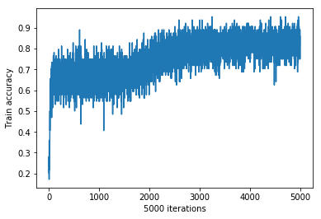

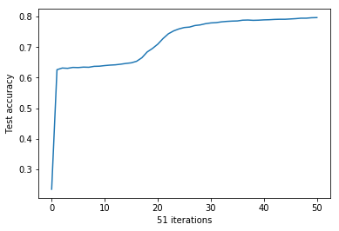

BATCH_SIZE= 32

iter 0: Train accuracy 0.09375 Test accuracy: 0.235 *

iter 100: Train accuracy 0.6875 Test accuracy: 0.6315 *

iter 200: Train accuracy 0.78125 Test accuracy: 0.6335 *

iter 300: Train accuracy 0.6875 Test accuracy: 0.6335

iter 400: Train accuracy 0.65625 Test accuracy: 0.635 *

iter 500: Train accuracy 0.65625 Test accuracy: 0.64 *

iter 600: Train accuracy 0.5625 Test accuracy: 0.6415 *

iter 700: Train accuracy 0.84375 Test accuracy: 0.647 *

iter 800: Train accuracy 0.78125 Test accuracy: 0.654 *

iter 900: Train accuracy 0.625 Test accuracy: 0.6885 *

iter 1000: Train accuracy 0.75 Test accuracy: 0.7105 *

iter 1100: Train accuracy 0.71875 Test accuracy: 0.745 *

iter 1200: Train accuracy 0.75 Test accuracy: 0.759 *

iter 1300: Train accuracy 0.78125 Test accuracy: 0.767 *

iter 1400: Train accuracy 0.84375 Test accuracy: 0.775 *

iter 1500: Train accuracy 0.78125 Test accuracy: 0.78 *

iter 1600: Train accuracy 0.84375 Test accuracy: 0.7815 *

iter 1700: Train accuracy 0.84375 Test accuracy: 0.7855 *

iter 1800: Train accuracy 0.75 Test accuracy: 0.7875 *

iter 1900: Train accuracy 0.75 Test accuracy: 0.788 *

iter 2000: Train accuracy 0.90625 Test accuracy: 0.7885 *

iter 2100: Train accuracy 0.84375 Test accuracy: 0.79 *

iter 2200: Train accuracy 0.8125 Test accuracy: 0.7915 *

iter 2300: Train accuracy 0.9375 Test accuracy: 0.7935 *

iter 2400: Train accuracy 0.8125 Test accuracy: 0.7945 *

iter 2500: Train accuracy 0.625 Test accuracy: 0.797 *

iter 2600: Train accuracy 0.8125 Test accuracy: 0.797

iter 2700: Train accuracy 0.90625 Test accuracy: 0.797

iter 2800: Train accuracy 0.71875 Test accuracy: 0.799 *

iter 2900: Train accuracy 0.875 Test accuracy: 0.8005 *

iter 3000: Train accuracy 0.65625 Test accuracy: 0.801 *

iter 3100: Train accuracy 0.71875 Test accuracy: 0.802 *

iter 3200: Train accuracy 0.84375 Test accuracy: 0.802

iter 3300: Train accuracy 0.78125 Test accuracy: 0.8035 *

iter 3400: Train accuracy 0.875 Test accuracy: 0.805 *

iter 3500: Train accuracy 0.78125 Test accuracy: 0.805

iter 3600: Train accuracy 0.84375 Test accuracy: 0.806 *

iter 3700: Train accuracy 0.8125 Test accuracy: 0.806

iter 3800: Train accuracy 0.84375 Test accuracy: 0.807 *

iter 3900: Train accuracy 0.71875 Test accuracy: 0.8085 *

iter 4000: Train accuracy 0.84375 Test accuracy: 0.809 *

iter 4100: Train accuracy 0.75 Test accuracy: 0.8085

iter 4200: Train accuracy 0.875 Test accuracy: 0.8085

iter 4300: Train accuracy 0.71875 Test accuracy: 0.8085

iter 4400: Train accuracy 0.90625 Test accuracy: 0.808

iter 4500: Train accuracy 0.875 Test accuracy: 0.809

iter 4600: Train accuracy 0.75 Test accuracy: 0.8095 *

iter 4700: Train accuracy 0.90625 Test accuracy: 0.81 *

iter 4800: Train accuracy 0.9375 Test accuracy: 0.81

iter 4900: Train accuracy 0.71875 Test accuracy: 0.8105 *

iter 4999: Train accuracy 0.875 Test accuracy: 0.81

Time usage: 0:15:05

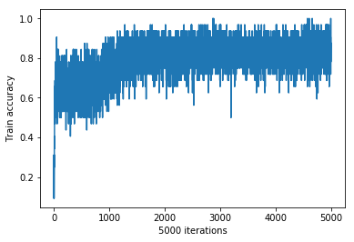



BATCH_SIZE= 16

iter 0: Train accuracy 0.25 Test accuracy: 0.235 *

iter 100: Train accuracy 0.625 Test accuracy: 0.6335 *

iter 200: Train accuracy 0.375 Test accuracy: 0.6345 *

iter 300: Train accuracy 0.75 Test accuracy: 0.642 *

iter 400: Train accuracy 0.4375 Test accuracy: 0.656 *

iter 500: Train accuracy 0.5625 Test accuracy: 0.7215 *

iter 600: Train accuracy 0.9375 Test accuracy: 0.7605 *

iter 700: Train accuracy 0.8125 Test accuracy: 0.7765 *

iter 800: Train accuracy 0.75 Test accuracy: 0.7805 *

iter 900: Train accuracy 0.6875 Test accuracy: 0.7885 *

iter 1000: Train accuracy 0.875 Test accuracy: 0.7885

iter 1100: Train accuracy 0.875 Test accuracy: 0.7925 *

iter 1200: Train accuracy 0.875 Test accuracy: 0.7945 *

iter 1300: Train accuracy 0.875 Test accuracy: 0.798 *

iter 1400: Train accuracy 0.9375 Test accuracy: 0.8 *

iter 1500: Train accuracy 0.8125 Test accuracy: 0.802 *

iter 1600: Train accuracy 0.75 Test accuracy: 0.804 *

iter 1700: Train accuracy 0.9375 Test accuracy: 0.805 *

iter 1800: Train accuracy 0.9375 Test accuracy: 0.806 *

iter 1900: Train accuracy 1 Test accuracy: 0.8065 *

iter 2000: Train accuracy 0.875 Test accuracy: 0.807 *

iter 2100: Train accuracy 0.875 Test accuracy: 0.808 *

iter 2200: Train accuracy 0.8125 Test accuracy: 0.8085 *

iter 2300: Train accuracy 0.8125 Test accuracy: 0.81 *

iter 2400: Train accuracy 0.9375 Test accuracy: 0.811 *

iter 2500: Train accuracy 0.625 Test accuracy: 0.8115 *

iter 2600: Train accuracy 0.875 Test accuracy: 0.811

iter 2700: Train accuracy 0.9375 Test accuracy: 0.8115

iter 2800: Train accuracy 0.875 Test accuracy: 0.8125 *

iter 2900: Train accuracy 0.9375 Test accuracy: 0.8125

iter 3000: Train accuracy 0.8125 Test accuracy: 0.812

iter 3100: Train accuracy 0.6875 Test accuracy: 0.813 *

iter 3200: Train accuracy 1 Test accuracy: 0.814 *

iter 3300: Train accuracy 0.9375 Test accuracy: 0.814

iter 3400: Train accuracy 0.8125 Test accuracy: 0.816 *

iter 3500: Train accuracy 0.9375 Test accuracy: 0.8155

iter 3600: Train accuracy 0.6875 Test accuracy: 0.8155

iter 3700: Train accuracy 1 Test accuracy: 0.8155

iter 3800: Train accuracy 0.9375 Test accuracy: 0.818 *

iter 3900: Train accuracy 0.8125 Test accuracy: 0.817

iter 4000: Train accuracy 0.9375 Test accuracy: 0.817

iter 4100: Train accuracy 0.9375 Test accuracy: 0.817

iter 4200: Train accuracy 0.75 Test accuracy: 0.8175

iter 4300: Train accuracy 0.9375 Test accuracy: 0.823 *

iter 4400: Train accuracy 0.75 Test accuracy: 0.8205

iter 4500: Train accuracy 0.9375 Test accuracy: 0.822

iter 4600: Train accuracy 0.8125 Test accuracy: 0.8225

iter 4700: Train accuracy 0.8125 Test accuracy: 0.823

iter 4800: Train accuracy 0.75 Test accuracy: 0.822

iter 4900: Train accuracy 1 Test accuracy: 0.8225

iter 4999: Train accuracy 0.8125 Test accuracy: 0.8225

Time usage: 0:29:36

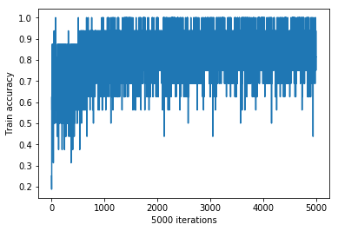



BATCH_SIZE= 8

iter 0: Train accuracy 0.25 Test accuracy: 0.235 *

iter 100: Train accuracy 0.5 Test accuracy: 0.634 *

iter 200: Train accuracy 0.625 Test accuracy: 0.6585 *

iter 300: Train accuracy 0.875 Test accuracy: 0.7635 *

iter 400: Train accuracy 0.75 Test accuracy: 0.7785 *

iter 500: Train accuracy 0.625 Test accuracy: 0.7895 *

iter 600: Train accuracy 0.75 Test accuracy: 0.795 *

iter 700: Train accuracy 0.875 Test accuracy: 0.8 *

iter 800: Train accuracy 0.875 Test accuracy: 0.8015 *

iter 900: Train accuracy 0.875 Test accuracy: 0.806 *

iter 1000: Train accuracy 0.875 Test accuracy: 0.808 *

iter 1100: Train accuracy 0.875 Test accuracy: 0.8095 *

iter 1200: Train accuracy 0.625 Test accuracy: 0.811 *

iter 1300: Train accuracy 1 Test accuracy: 0.8125 *

iter 1400: Train accuracy 0.875 Test accuracy: 0.8115

iter 1500: Train accuracy 1 Test accuracy: 0.811

iter 1600: Train accuracy 1 Test accuracy: 0.813 *

iter 1700: Train accuracy 1 Test accuracy: 0.813

iter 1800: Train accuracy 0.625 Test accuracy: 0.816 *

iter 1900: Train accuracy 0.75 Test accuracy: 0.8175 *

iter 2000: Train accuracy 0.5 Test accuracy: 0.816

iter 2100: Train accuracy 0.875 Test accuracy: 0.8205 *

iter 2200: Train accuracy 0.875 Test accuracy: 0.822 *

iter 2300: Train accuracy 0.875 Test accuracy: 0.8225 *

iter 2400: Train accuracy 0.875 Test accuracy: 0.823 *

iter 2500: Train accuracy 0.875 Test accuracy: 0.825 *

iter 2600: Train accuracy 0.875 Test accuracy: 0.8225

iter 2700: Train accuracy 0.875 Test accuracy: 0.824

iter 2800: Train accuracy 0.875 Test accuracy: 0.824

iter 2900: Train accuracy 0.875 Test accuracy: 0.824

iter 3000: Train accuracy 0.875 Test accuracy: 0.824

iter 3100: Train accuracy 1 Test accuracy: 0.826 *

iter 3200: Train accuracy 1 Test accuracy: 0.8255

iter 3300: Train accuracy 0.625 Test accuracy: 0.827 *

iter 3400: Train accuracy 1 Test accuracy: 0.826

iter 3500: Train accuracy 1 Test accuracy: 0.8275 *

iter 3600: Train accuracy 0.875 Test accuracy: 0.825

iter 3700: Train accuracy 0.75 Test accuracy: 0.826

iter 3800: Train accuracy 0.875 Test accuracy: 0.827

iter 3900: Train accuracy 0.75 Test accuracy: 0.827

iter 4000: Train accuracy 0.75 Test accuracy: 0.827

iter 4100: Train accuracy 1 Test accuracy: 0.8285 *

iter 4200: Train accuracy 0.75 Test accuracy: 0.829 *

iter 4300: Train accuracy 0.875 Test accuracy: 0.829

iter 4400: Train accuracy 0.875 Test accuracy: 0.83 *

iter 4500: Train accuracy 0.875 Test accuracy: 0.829

iter 4600: Train accuracy 0.75 Test accuracy: 0.8305 *

iter 4700: Train accuracy 0.875 Test accuracy: 0.832 *

iter 4800: Train accuracy 0.75 Test accuracy: 0.8305

iter 4900: Train accuracy 0.875 Test accuracy: 0.831

iter 4999: Train accuracy 0.75 Test accuracy: 0.8305

Time usage: 0:58:37

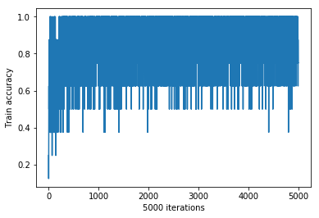



BATCH_SIZE= 4

iter 0: Train accuracy 0.5 Test accuracy: 0.254 *

iter 100: Train accuracy 0.75 Test accuracy: 0.657 *

iter 200: Train accuracy 0.5 Test accuracy: 0.783 *

iter 300: Train accuracy 1 Test accuracy: 0.793 *

iter 400: Train accuracy 0.75 Test accuracy: 0.804 *

iter 500: Train accuracy 1 Test accuracy: 0.8085 *

iter 600: Train accuracy 1 Test accuracy: 0.809 *

iter 700: Train accuracy 0.75 Test accuracy: 0.812 *

iter 800: Train accuracy 1 Test accuracy: 0.8115

iter 900: Train accuracy 1 Test accuracy: 0.8135 *

iter 1000: Train accuracy 0.75 Test accuracy: 0.8175 *

iter 1100: Train accuracy 0.75 Test accuracy: 0.8195 *

iter 1200: Train accuracy 0.75 Test accuracy: 0.818

iter 1300: Train accuracy 0.75 Test accuracy: 0.823 *

iter 1400: Train accuracy 1 Test accuracy: 0.825 *

iter 1500: Train accuracy 0.75 Test accuracy: 0.8255 *

iter 1600: Train accuracy 1 Test accuracy: 0.8255

iter 1700: Train accuracy 1 Test accuracy: 0.826 *

iter 1800: Train accuracy 1 Test accuracy: 0.8255

iter 1900: Train accuracy 0.75 Test accuracy: 0.8295 *

iter 2000: Train accuracy 1 Test accuracy: 0.83 *

iter 2100: Train accuracy 0.75 Test accuracy: 0.829

iter 2200: Train accuracy 0.5 Test accuracy: 0.83

iter 2300: Train accuracy 0.75 Test accuracy: 0.83

iter 2400: Train accuracy 1 Test accuracy: 0.83

iter 2500: Train accuracy 0.75 Test accuracy: 0.8305 *

iter 2600: Train accuracy 0.75 Test accuracy: 0.833 *

iter 2700: Train accuracy 1 Test accuracy: 0.832

iter 2800: Train accuracy 0.75 Test accuracy: 0.834 *

iter 2900: Train accuracy 0.75 Test accuracy: 0.8365 *

iter 3000: Train accuracy 0.75 Test accuracy: 0.837 *

iter 3100: Train accuracy 0.75 Test accuracy: 0.84 *

iter 3200: Train accuracy 0.75 Test accuracy: 0.8385

iter 3300: Train accuracy 0.5 Test accuracy: 0.8405 *

iter 3400: Train accuracy 1 Test accuracy: 0.8385

iter 3500: Train accuracy 0.75 Test accuracy: 0.8405

iter 3600: Train accuracy 1 Test accuracy: 0.841 *

iter 3700: Train accuracy 0.75 Test accuracy: 0.843 *

iter 3800: Train accuracy 1 Test accuracy: 0.8415

iter 3900: Train accuracy 1 Test accuracy: 0.8435 *

iter 4000: Train accuracy 1 Test accuracy: 0.8415

iter 4100: Train accuracy 1 Test accuracy: 0.841

iter 4200: Train accuracy 0.75 Test accuracy: 0.84

iter 4300: Train accuracy 1 Test accuracy: 0.8415

iter 4400: Train accuracy 0.5 Test accuracy: 0.8415

iter 4500: Train accuracy 0.75 Test accuracy: 0.841

iter 4600: Train accuracy 1 Test accuracy: 0.841

iter 4700: Train accuracy 1 Test accuracy: 0.841

iter 4800: Train accuracy 1 Test accuracy: 0.8405

iter 4900: Train accuracy 1 Test accuracy: 0.8405

iter 4999: Train accuracy 1 Test accuracy: 0.841

Time usage: 1:56:37

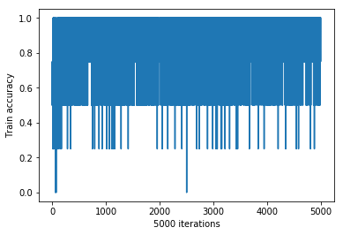



BATCH_SIZE= 64

iter 0: Train accuracy 0.28125 Test accuracy: 0.235 *

iter 100: Train accuracy 0.671875 Test accuracy: 0.626 *

iter 200: Train accuracy 0.734375 Test accuracy: 0.6295 *

iter 300: Train accuracy 0.71875 Test accuracy: 0.6305 *

iter 400: Train accuracy 0.640625 Test accuracy: 0.6335 *

iter 500: Train accuracy 0.65625 Test accuracy: 0.634 *

iter 600: Train accuracy 0.703125 Test accuracy: 0.6345 *

iter 700: Train accuracy 0.71875 Test accuracy: 0.6345

iter 800: Train accuracy 0.703125 Test accuracy: 0.637 *

iter 900: Train accuracy 0.703125 Test accuracy: 0.637

iter 1000: Train accuracy 0.625 Test accuracy: 0.6395 *

iter 1100: Train accuracy 0.65625 Test accuracy: 0.642 *

iter 1200: Train accuracy 0.71875 Test accuracy: 0.6415

iter 1300: Train accuracy 0.546875 Test accuracy: 0.6445 *

iter 1400: Train accuracy 0.734375 Test accuracy: 0.6465 *

iter 1500: Train accuracy 0.703125 Test accuracy: 0.65 *

iter 1600: Train accuracy 0.71875 Test accuracy: 0.654 *

iter 1700: Train accuracy 0.734375 Test accuracy: 0.672 *

iter 1800: Train accuracy 0.796875 Test accuracy: 0.6875 *

iter 1900: Train accuracy 0.734375 Test accuracy: 0.697 *

iter 2000: Train accuracy 0.640625 Test accuracy: 0.714 *

iter 2100: Train accuracy 0.765625 Test accuracy: 0.732 *

iter 2200: Train accuracy 0.765625 Test accuracy: 0.7465 *

iter 2300: Train accuracy 0.859375 Test accuracy: 0.7545 *

iter 2400: Train accuracy 0.78125 Test accuracy: 0.7605 *

iter 2500: Train accuracy 0.8125 Test accuracy: 0.764 *

iter 2600: Train accuracy 0.796875 Test accuracy: 0.766 *

iter 2700: Train accuracy 0.8125 Test accuracy: 0.771 *

iter 2800: Train accuracy 0.875 Test accuracy: 0.775 *

iter 2900: Train accuracy 0.890625 Test accuracy: 0.778 *

iter 3000: Train accuracy 0.84375 Test accuracy: 0.7785 *

iter 3100: Train accuracy 0.75 Test accuracy: 0.78 *

iter 3200: Train accuracy 0.75 Test accuracy: 0.7815 *

iter 3300: Train accuracy 0.78125 Test accuracy: 0.782 *

iter 3400: Train accuracy 0.78125 Test accuracy: 0.785 *

iter 3500: Train accuracy 0.8125 Test accuracy: 0.7865 *

iter 3600: Train accuracy 0.703125 Test accuracy: 0.7875 *

iter 3700: Train accuracy 0.8125 Test accuracy: 0.7885 *

iter 3800: Train accuracy 0.859375 Test accuracy: 0.7885

iter 3900: Train accuracy 0.734375 Test accuracy: 0.7875

iter 4000: Train accuracy 0.71875 Test accuracy: 0.789 *

iter 4100: Train accuracy 0.796875 Test accuracy: 0.79 *

iter 4200: Train accuracy 0.828125 Test accuracy: 0.791 *

iter 4300: Train accuracy 0.828125 Test accuracy: 0.792 *

iter 4400: Train accuracy 0.734375 Test accuracy: 0.792

iter 4500: Train accuracy 0.796875 Test accuracy: 0.792

iter 4600: Train accuracy 0.84375 Test accuracy: 0.7935 *

iter 4700: Train accuracy 0.8125 Test accuracy: 0.794 *

iter 4800: Train accuracy 0.828125 Test accuracy: 0.7945 *

iter 4900: Train accuracy 0.765625 Test accuracy: 0.796 *

iter 4999: Train accuracy 0.8125 Test accuracy: 0.7965 *

Time usage: 0:07:50

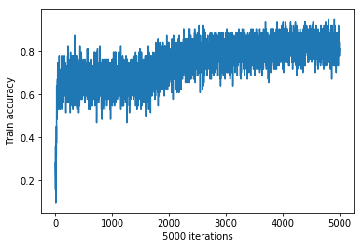

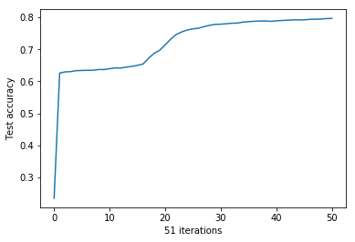

BATCH_SIZE= 32

iter 0: Train accuracy 0.125 Test accuracy: 0.235 *

iter 100: Train accuracy 0.65625 Test accuracy: 0.6295 *

iter 200: Train accuracy 0.6875 Test accuracy: 0.634 *

iter 300: Train accuracy 0.78125 Test accuracy: 0.6335

iter 400: Train accuracy 0.6875 Test accuracy: 0.637 *

iter 500: Train accuracy 0.71875 Test accuracy: 0.64 *

iter 600: Train accuracy 0.6875 Test accuracy: 0.641 *

iter 700: Train accuracy 0.71875 Test accuracy: 0.647 *

iter 800: Train accuracy 0.65625 Test accuracy: 0.6545 *

iter 900: Train accuracy 0.6875 Test accuracy: 0.684 *

iter 1000: Train accuracy 0.75 Test accuracy: 0.716 *

iter 1100: Train accuracy 0.71875 Test accuracy: 0.747 *

iter 1200: Train accuracy 0.875 Test accuracy: 0.7605 *

iter 1300: Train accuracy 0.875 Test accuracy: 0.766 *

iter 1400: Train accuracy 0.71875 Test accuracy: 0.7745 *

iter 1500: Train accuracy 0.9375 Test accuracy: 0.78 *

iter 1600: Train accuracy 0.84375 Test accuracy: 0.7825 *

iter 1700: Train accuracy 0.90625 Test accuracy: 0.786 *

iter 1800: Train accuracy 0.9375 Test accuracy: 0.7875 *

iter 1900: Train accuracy 0.8125 Test accuracy: 0.7875

iter 2000: Train accuracy 0.78125 Test accuracy: 0.789 *

iter 2100: Train accuracy 0.96875 Test accuracy: 0.791 *

iter 2200: Train accuracy 0.8125 Test accuracy: 0.7915 *

iter 2300: Train accuracy 0.90625 Test accuracy: 0.7935 *

iter 2400: Train accuracy 0.84375 Test accuracy: 0.795 *

iter 2500: Train accuracy 0.84375 Test accuracy: 0.797 *

iter 2600: Train accuracy 0.75 Test accuracy: 0.797

iter 2700: Train accuracy 0.875 Test accuracy: 0.7975 *

iter 2800: Train accuracy 0.65625 Test accuracy: 0.7995 *

iter 2900: Train accuracy 0.8125 Test accuracy: 0.801 *

iter 3000: Train accuracy 0.875 Test accuracy: 0.8015 *

iter 3100: Train accuracy 0.875 Test accuracy: 0.802 *

iter 3200: Train accuracy 0.875 Test accuracy: 0.803 *

iter 3300: Train accuracy 0.9375 Test accuracy: 0.8045 *

iter 3400: Train accuracy 0.90625 Test accuracy: 0.806 *

iter 3500: Train accuracy 0.8125 Test accuracy: 0.805

iter 3600: Train accuracy 0.8125 Test accuracy: 0.807 *

iter 3700: Train accuracy 0.875 Test accuracy: 0.8065

iter 3800: Train accuracy 0.875 Test accuracy: 0.807

iter 3900: Train accuracy 0.75 Test accuracy: 0.807

iter 4000: Train accuracy 0.875 Test accuracy: 0.8075 *

iter 4100: Train accuracy 0.90625 Test accuracy: 0.809 *

iter 4200: Train accuracy 0.8125 Test accuracy: 0.8085

iter 4300: Train accuracy 0.90625 Test accuracy: 0.8075

iter 4400: Train accuracy 0.90625 Test accuracy: 0.808

iter 4500: Train accuracy 0.90625 Test accuracy: 0.8085

iter 4600: Train accuracy 0.84375 Test accuracy: 0.809

iter 4700: Train accuracy 0.84375 Test accuracy: 0.8095 *

iter 4800: Train accuracy 0.90625 Test accuracy: 0.809

iter 4900: Train accuracy 0.8125 Test accuracy: 0.8105 *

iter 4999: Train accuracy 0.84375 Test accuracy: 0.8105

Time usage: 0:16:00

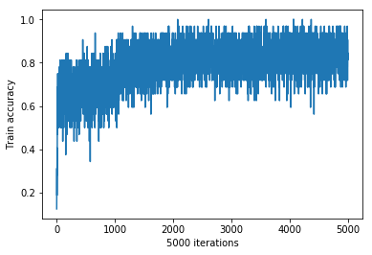

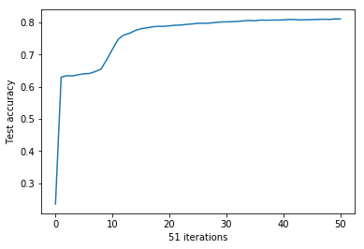

BATCH_SIZE= 16

iter 0: Train accuracy 0.0625 Test accuracy: 0.235 *

iter 100: Train accuracy 0.625 Test accuracy: 0.633 *

iter 200: Train accuracy 0.625 Test accuracy: 0.6355 *

iter 300: Train accuracy 0.6875 Test accuracy: 0.6415 *

iter 400: Train accuracy 0.75 Test accuracy: 0.654 *

iter 500: Train accuracy 0.6875 Test accuracy: 0.7155 *

iter 600: Train accuracy 0.75 Test accuracy: 0.76 *

iter 700: Train accuracy 0.875 Test accuracy: 0.7745 *

iter 800: Train accuracy 0.625 Test accuracy: 0.7835 *

iter 900: Train accuracy 0.9375 Test accuracy: 0.7855 *

iter 1000: Train accuracy 0.625 Test accuracy: 0.789 *

iter 1100: Train accuracy 0.8125 Test accuracy: 0.7915 *

iter 1200: Train accuracy 0.75 Test accuracy: 0.7955 *

iter 1300: Train accuracy 0.75 Test accuracy: 0.797 *

iter 1400: Train accuracy 0.75 Test accuracy: 0.8005 *

iter 1500: Train accuracy 0.875 Test accuracy: 0.8015 *

iter 1600: Train accuracy 0.9375 Test accuracy: 0.803 *

iter 1700: Train accuracy 0.6875 Test accuracy: 0.8065 *

iter 1800: Train accuracy 0.625 Test accuracy: 0.8065

iter 1900: Train accuracy 0.875 Test accuracy: 0.8075 *

iter 2000: Train accuracy 0.75 Test accuracy: 0.809 *

iter 2100: Train accuracy 0.75 Test accuracy: 0.808

iter 2200: Train accuracy 0.625 Test accuracy: 0.8085

iter 2300: Train accuracy 1 Test accuracy: 0.809

iter 2400: Train accuracy 0.8125 Test accuracy: 0.8105 *

iter 2500: Train accuracy 0.75 Test accuracy: 0.81

iter 2600: Train accuracy 0.9375 Test accuracy: 0.811 *

iter 2700: Train accuracy 0.75 Test accuracy: 0.8115 *

iter 2800: Train accuracy 0.8125 Test accuracy: 0.811

iter 2900: Train accuracy 0.875 Test accuracy: 0.812 *

iter 3000: Train accuracy 0.8125 Test accuracy: 0.8125 *

iter 3100: Train accuracy 0.8125 Test accuracy: 0.813 *

iter 3200: Train accuracy 0.875 Test accuracy: 0.813

iter 3300: Train accuracy 0.875 Test accuracy: 0.8145 *

iter 3400: Train accuracy 0.8125 Test accuracy: 0.8145

iter 3500: Train accuracy 0.875 Test accuracy: 0.816 *

iter 3600: Train accuracy 0.9375 Test accuracy: 0.816

iter 3700: Train accuracy 0.8125 Test accuracy: 0.816

iter 3800: Train accuracy 0.6875 Test accuracy: 0.818 *

iter 3900: Train accuracy 0.8125 Test accuracy: 0.8175

iter 4000: Train accuracy 0.9375 Test accuracy: 0.8195 *

iter 4100: Train accuracy 0.8125 Test accuracy: 0.8195

iter 4200: Train accuracy 0.875 Test accuracy: 0.8185

iter 4300: Train accuracy 0.875 Test accuracy: 0.8225 *

iter 4400: Train accuracy 0.8125 Test accuracy: 0.82

iter 4500: Train accuracy 0.8125 Test accuracy: 0.8215

iter 4600: Train accuracy 0.8125 Test accuracy: 0.8225

iter 4700: Train accuracy 0.8125 Test accuracy: 0.8215

iter 4800: Train accuracy 0.8125 Test accuracy: 0.8225

iter 4900: Train accuracy 0.75 Test accuracy: 0.822

iter 4999: Train accuracy 0.875 Test accuracy: 0.8225

Time usage: 0:30:16

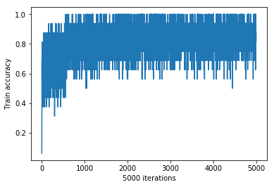

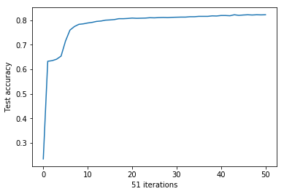

BATCH_SIZE= 8

iter 0: Train accuracy 0.125 Test accuracy: 0.235 *

iter 100: Train accuracy 0.375 Test accuracy: 0.6335 *

iter 200: Train accuracy 0.5 Test accuracy: 0.656 *

iter 300: Train accuracy 0.625 Test accuracy: 0.762 *

iter 400: Train accuracy 0.875 Test accuracy: 0.7825 *

iter 500: Train accuracy 0.875 Test accuracy: 0.7885 *

iter 600: Train accuracy 0.875 Test accuracy: 0.7945 *

iter 700: Train accuracy 0.875 Test accuracy: 0.7995 *

iter 800: Train accuracy 0.75 Test accuracy: 0.8045 *

iter 900: Train accuracy 0.75 Test accuracy: 0.8075 *

iter 1000: Train accuracy 1 Test accuracy: 0.81 *

iter 1100: Train accuracy 0.875 Test accuracy: 0.8085

iter 1200: Train accuracy 1 Test accuracy: 0.811 *

iter 1300: Train accuracy 1 Test accuracy: 0.8115 *

iter 1400: Train accuracy 1 Test accuracy: 0.812 *

iter 1500: Train accuracy 0.875 Test accuracy: 0.8115

iter 1600: Train accuracy 0.875 Test accuracy: 0.813 *

iter 1700: Train accuracy 1 Test accuracy: 0.8155 *

iter 1800: Train accuracy 0.875 Test accuracy: 0.817 *

iter 1900: Train accuracy 0.75 Test accuracy: 0.818 *

iter 2000: Train accuracy 0.875 Test accuracy: 0.8175

iter 2100: Train accuracy 1 Test accuracy: 0.8205 *

iter 2200: Train accuracy 0.875 Test accuracy: 0.8195

iter 2300: Train accuracy 0.875 Test accuracy: 0.822 *

iter 2400: Train accuracy 0.75 Test accuracy: 0.8205

iter 2500: Train accuracy 0.875 Test accuracy: 0.822

iter 2600: Train accuracy 0.75 Test accuracy: 0.822

iter 2700: Train accuracy 1 Test accuracy: 0.8225 *

iter 2800: Train accuracy 0.875 Test accuracy: 0.8245 *

iter 2900: Train accuracy 1 Test accuracy: 0.8235

iter 3000: Train accuracy 0.875 Test accuracy: 0.8235

iter 3100: Train accuracy 0.75 Test accuracy: 0.8255 *

iter 3200: Train accuracy 0.875 Test accuracy: 0.8245

iter 3300: Train accuracy 0.875 Test accuracy: 0.825

iter 3400: Train accuracy 0.875 Test accuracy: 0.8255

iter 3500: Train accuracy 1 Test accuracy: 0.825

iter 3600: Train accuracy 0.625 Test accuracy: 0.826 *

iter 3700: Train accuracy 0.75 Test accuracy: 0.8265 *

iter 3800: Train accuracy 0.875 Test accuracy: 0.827 *

iter 3900: Train accuracy 0.75 Test accuracy: 0.8265

iter 4000: Train accuracy 0.875 Test accuracy: 0.8255

iter 4100: Train accuracy 1 Test accuracy: 0.8285 *

iter 4200: Train accuracy 0.75 Test accuracy: 0.8285

iter 4300: Train accuracy 0.875 Test accuracy: 0.8285

iter 4400: Train accuracy 1 Test accuracy: 0.8305 *

iter 4500: Train accuracy 0.875 Test accuracy: 0.83

iter 4600: Train accuracy 0.875 Test accuracy: 0.8305

iter 4700: Train accuracy 0.875 Test accuracy: 0.831 *

iter 4800: Train accuracy 0.75 Test accuracy: 0.83

iter 4900: Train accuracy 0.875 Test accuracy: 0.83

iter 4999: Train accuracy 1 Test accuracy: 0.8305

Time usage: 0:59:02

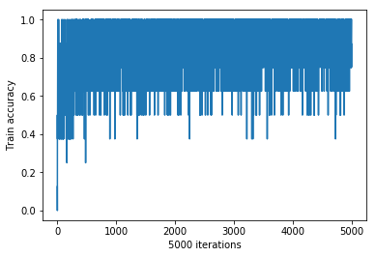

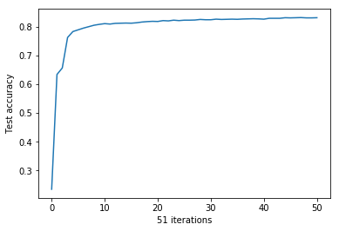

BATCH_SIZE= 4

iter 0: Train accuracy 0.75 Test accuracy: 0.312 *

iter 100: Train accuracy 0.5 Test accuracy: 0.651 *

iter 200: Train accuracy 0.75 Test accuracy: 0.7795 *

iter 300: Train accuracy 1 Test accuracy: 0.795 *

iter 400: Train accuracy 1 Test accuracy: 0.805 *

iter 500: Train accuracy 1 Test accuracy: 0.809 *

iter 600: Train accuracy 1 Test accuracy: 0.8095 *

iter 700: Train accuracy 1 Test accuracy: 0.813 *

iter 800: Train accuracy 1 Test accuracy: 0.813

iter 900: Train accuracy 0.75 Test accuracy: 0.8145 *

iter 1000: Train accuracy 0.75 Test accuracy: 0.8215 *

iter 1100: Train accuracy 0.75 Test accuracy: 0.819

iter 1200: Train accuracy 1 Test accuracy: 0.8215

iter 1300: Train accuracy 1 Test accuracy: 0.8235 *

iter 1400: Train accuracy 0.75 Test accuracy: 0.825 *

iter 1500: Train accuracy 1 Test accuracy: 0.8245

iter 1600: Train accuracy 1 Test accuracy: 0.825

iter 1700: Train accuracy 0.75 Test accuracy: 0.8235

iter 1800: Train accuracy 1 Test accuracy: 0.8275 *

iter 1900: Train accuracy 0.75 Test accuracy: 0.828 *

iter 2000: Train accuracy 0.75 Test accuracy: 0.8295 *

iter 2100: Train accuracy 1 Test accuracy: 0.8285

iter 2200: Train accuracy 0.5 Test accuracy: 0.83 *

iter 2300: Train accuracy 0.75 Test accuracy: 0.8325 *

iter 2400: Train accuracy 0.75 Test accuracy: 0.8315

iter 2500: Train accuracy 1 Test accuracy: 0.831

iter 2600: Train accuracy 0.75 Test accuracy: 0.834 *

iter 2700: Train accuracy 0.75 Test accuracy: 0.833

iter 2800: Train accuracy 1 Test accuracy: 0.8365 *

iter 2900: Train accuracy 0.75 Test accuracy: 0.8355

iter 3000: Train accuracy 1 Test accuracy: 0.839 *

iter 3100: Train accuracy 1 Test accuracy: 0.838

iter 3200: Train accuracy 1 Test accuracy: 0.84 *

iter 3300: Train accuracy 1 Test accuracy: 0.839

iter 3400: Train accuracy 0.75 Test accuracy: 0.8395

iter 3500: Train accuracy 1 Test accuracy: 0.84

iter 3600: Train accuracy 0.5 Test accuracy: 0.8395

iter 3700: Train accuracy 1 Test accuracy: 0.8415 *

iter 3800: Train accuracy 0.75 Test accuracy: 0.839

iter 3900: Train accuracy 0.75 Test accuracy: 0.8395

iter 4000: Train accuracy 0.25 Test accuracy: 0.843 *

iter 4100: Train accuracy 1 Test accuracy: 0.8435 *

iter 4200: Train accuracy 0.75 Test accuracy: 0.8425

iter 4300: Train accuracy 0.5 Test accuracy: 0.842

iter 4400: Train accuracy 0.75 Test accuracy: 0.8415

iter 4500: Train accuracy 1 Test accuracy: 0.8435

iter 4600: Train accuracy 1 Test accuracy: 0.8405

iter 4700: Train accuracy 1 Test accuracy: 0.84

iter 4800: Train accuracy 1 Test accuracy: 0.8435

iter 4900: Train accuracy 1 Test accuracy: 0.8415

iter 4999: Train accuracy 0.75 Test accuracy: 0.8445 *

Time usage: 1:57:38

